

CZ2006 - Software Engineering

**Software Requirements Specifications**

Project Name: Hungry Spoon Mobile Application

Group Name / Lab Group: Quartz / SSP5

Date of submission:

|  |  |
| --- | --- |
| **Group Members** | **Matriculation Number** |
| Koh Liang Jing | U1820617C |
| Roxas Abby Maurea Imus | U1822611H |
| Karen Wong Ke Xin | U1822961B |
| Nihed Harrak | N1903619E |
| Gwyn Bong Xiao Min | U1821320K |

**Table of contents**

Revision History 3

1. Introduction 4

1.1 Purpose 4

1.2 Document Conventions 4

1.3 Intended Audience and reading suggestions 4

1.4 Product scope 5

2. Overall Description 6

2.1 Product Perspective 6

2.2 Product Function 7

2.3 Design and Implementation Constraints 7

2.4 Assumption 7

3. System Features 8

3.1 Functional Requirements 8

**3.1.1** **Generation of Eateries** 8

**3.1.2 Calories counter and exercise recommendation** 8

**3.1.3 Other functionalities** 8

3.2 Non-Functional Requirements 9

**3.2.1 Performance Requirement** 9

**3.2.2 Usability Requirements** 9

**3.2.3 Reliability Requirements** 9

**3.2.4 Supportability** 9

4.Use Case Model and description 10

4.1 Use Case Model 10

4.2 Use Case Description 11

**4.2.1 Account creation** 11

**4.2.2 Update account details** 12

**4.2.3 Food generator** 13

**4.2.4 Locating Parks** 14

**4.2.5 Calories counter and Exercise Recommendation** 15

6.1 Account Login and Update 18

6.2 Food Generator 19

6.3 Locating Parks 20

6.4 Calories Counter and Exercise Recommendation 21

7. System Architecture 24

8. Test Cases 25

9. Appendix 26

9.2 Data dictionary 26

9.3 UI Mockup 28

**Revision History**

|  |  |  |
| --- | --- | --- |
| **Date:** | **Description:** | **Amended by:** |
| 18/10/19 | Software requirement specification documents V1.   * Set up the basic format and sequence. | Karen Wong |
| 30/10/19 | Software requirement specification documents V2.   * Update section 1,2 and 3. * Update use case models. | Karen Wong |
| 07/11/19 | Software requirement specification documents V3.   * Add in the sequence diagram. * Add in updated use case diagram and description. | Liang Jing |
| 13/11/19 | Software requirement specification documents V4.   * Paste in testcases and updated class diagram image. * Amend functional requirements. | Liang Jing |
| 13/11/19 | Software requirement specification documents V4.   * Amend the format of the SRS and some diagram. | Karen Wong |

1. **Introduction**

This document served as a software requirements specification (SRS) documentation for the implementation of HungrySpoon Food Application.

## **Purpose**

The purpose of the document is to provide a brief introduction to the functionalities of HungrySpoon application. HungrySpoon is an android application that recommend food eateries through a random generator and allow user to check the total amount of calories consumed. It will then provide recommended duration of exercise based on calories consumed. This report will include project’s intention, objective and functional and non-functional requirements. As well as brief summary of the implementation design.

## **Document Conventions**

The below table will provide the document convention used in this report.

|  |  |
| --- | --- |
| **Front used** | **Meaning** |
| Times New Roman, 12 | Content |
| Times New Roman, 13 | Level 2 header |
| Times New Roman, 14 | Level 1 header |

Table 1-Typographical convention

## **Intended Audience and reading suggestions**

This document is intended for key stakeholders involved in the project. It provides an introduction to the project and its functionalities. Hence, it will be suitable for both the development team and intended users of this application. As well as potential non-profit organization as fund provider such as the health promotion board.

It is recommended that reader read from the beginning to the end to get an understanding of the reason and structure of the application. Marketing staffs, user and potential investment may want to spend more time on the second section which provide a summary of the functionalities and the objectives and benefits of this application. While tester and developer should spend more time on the third section as it contains necessary documents to understand the structure of the application.

The below table identify the application’s key stakeholders.

|  |  |  |
| --- | --- | --- |
| **Stakeholders** | **Interest** | **Involvement** |
| User | Using the application which might provide convenience of deciding where to eat. | User of HungrySpon application. |
| Health promotion board | Promoting a healthier Singapore | Food calories database provider and financial support. |
| Developer | Provide necessary information to understand the components of the HungrySpoon application. Which will be helpful during the development of the application. | Developing HungrySpoon application. |
| Tester | Understand how application works and the use cases related to the application. | Testing of key functionalities of the application. |

Table 2 -Key stakeholders of this application

## **Product scope**

Description of product

The proposed system objective is to implements a mobile application which will provide recommendation on food eateries, location of outdoor facilities and recommended exercise based on calories consumed.

As it will generate food eateries one at a time from a generated list based on user’s preference, more priority will be given to healthier and cultural eateries. This hope to increase people exposure to cultural and healthy eateries. Aside from that, the application provides a function of calculating calories consumed and provide a recommendation of exercise duration based on the exercise intensity and total calories count.

Mission

Encourage people to adopt healthier lifestyle and embrace heritage through food by dealing with common issue of being indecisive when eating out.

Objective and benefits

The objective of this project is to encourage more people to adopt a healthier lifestyle by providing an application that capitalized on the common millennial problem of not knowing where to eat.

With the application, it will provide a ‘fun’ way for user to discover more eateries around Singapore which may contain cultural significant or a healthier option. Aside from that, to encourage healthy lifestyle, the application provides the convenience of checking calories and recommendation of exercise timing and the places where they can burn off calories around the eateries or their input location.

Being healthy is not difficult when user decide to start small and this application encourage user to do so by providing access to such information at the tips of their fingers. Hence, with this application, it hopes to encourage people in Singapore to explore more of their cultural heritage through food and movement after a meal.

1. **Overall Description**

In this section, it will provide more cover on the product’s functionalities and implementing means.

* 1. **Product Perspective**

HungrySpoon application is an improved version of the “diet tracker” in the existing Healthy 365 mobile application provided by the Health Promotion Board. HungrySpoon will emphasize on user friendliness, by making it more straightforward for user to key in and get the necessary information such as the total calories and exercise timing.

Aside from that, HungrySpoon aim to provide a convenience application for user to not only track calories intake and exercise but also, recommend parks or outdoor exercise facilities around the area. With the access to information, it aims to make going out to burn calories easier.

* 1. **Product Function**

HungrySpoon application consist of 3 main features:

1. **Food generator:** Application will ask for user’s location. User can make use of filters to state requirements. System will recommend places one at a time based on the user’s input data. System will continue to show eateries from a list created based on user preference until the user cancel or accept recommendation.
2. **Calories Tracker + Exercise Recommendation:** This function allow user to add in what they had for meal and calculate the total calories they consumed. Afterwards, it will display both the total calories consumed and the recommended brisk walk timing.
3. **Locate Park:** This function takes in user’s location based on input and display nearby outdoor facilities user can exercise or walk around.
   1. **Design and Implementation Constraints**
4. Data on dishes/food item’s calories count (especially food details of local food dishes).
5. In the implementation, the lack of the vast food database (APIs) that the health promotion board current has.
6. As each person’s physic varies, recommendation of exercise based on calories count and BMI, is a rough estimation only.
7. Total calories calculated is based on a rough estimate where food item’s calories taken from database. It does not accurately reflect a person calories intake, but it will provide a rough estimation.
   1. **Assumption**

1.The project team obtain relevant dataset and APIs required for this project:

1. Food item’s calories dataset

2. NParks APIs

3. Healthy Eateries APIs

4. Hawker Centers APIs

2. For google map redirect, assume that recommended food eateries can be found in google map with relevant information.

3. Assume that user input location within Singapore

1. **System Features**

Under this section, it will elaborate on the functional, non-functional requirements of the application. As well as providing the necessary documents

* 1. **Functional Requirements** 
     1. **Generation of Eateries**

1. The user must be able to input their location.
2. The system must be able to generate a list of eateries based on the user’s input location.
3. The system must display a random eatery from the generated list of eateries to the user.
4. The user must be able to accept or decline the suggested eatery.
5. When the user declines a suggested eatery, the system must display another from the generated list.
6. The system must allow the user to be redirected to Google maps for directions to the eatery.

### **3.1.2 Calories counter and exercise recommendation**

1. The system must be able to store the height and weight of a user upon its first use.
2. The user must be able to input food that they have consumed.
3. The system must be able to calculate the total calories consumed by the user.
4. The system must be able to provide recommended exercises based on the total amount of calories.
5. The user must be able to input their locations to find the nearest park.
6. The system must be able to display park’s location.

### **3.1.3 Other functionalities**

1. The system must have a bottom navigation for easy access to functions.
2. System must be able to create an account for each device user that store the basic information such as name, height and weight.
   1. **Non-Functional Requirements**

This section will contain the non-functional requirements for this application.

### **3.2.1 Performance Requirement**

1. When the user enters a location, the system must be able to match the input with a valid location in the database (API) within a minute.
2. The system must be able to provide suggestions based on the user’s input should as location and filters accurately.
3. The system must be able to continuously provide the recommendation from the generated list until the user exit or accept the recommendation.
4. The mobile application shouldn’t take more than 3 seconds to load screen.

### **3.2.2 Usability Requirements**

1. The system must offer informative and concise feedback.
2. The system must only show eateries and parks in Singapore.

### **3.2.3 Reliability Requirements**

1. The system must respond to the user’s location input within 5 seconds.
2. The system must redirect to google maps within 2 seconds if the user opts to be directed.

### **3.2.4 Supportability**

1. The system must be able to work with external databases such as APIs and dataset to provide services.
2. The system must be able to work with Android 6.0 “Marshmallow”.

# **4.Use Case Model and description**

In the below section, it will include the use case model for the HungrySpoon mobile application as well as the use case description for the key functionalities

## **Use Case Model**

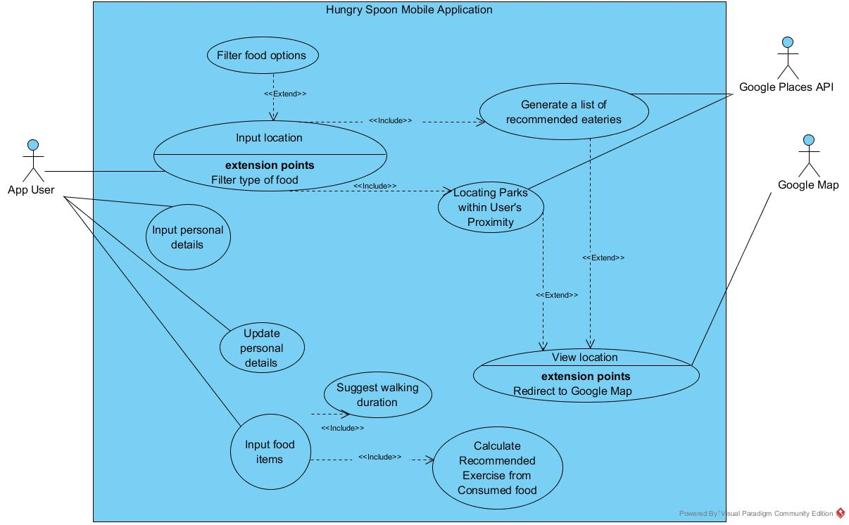

Figure 1- Use Case Diagram for HungrySpoon

## **4.2 Use Case Description**

### **4.2.1 Account creation**

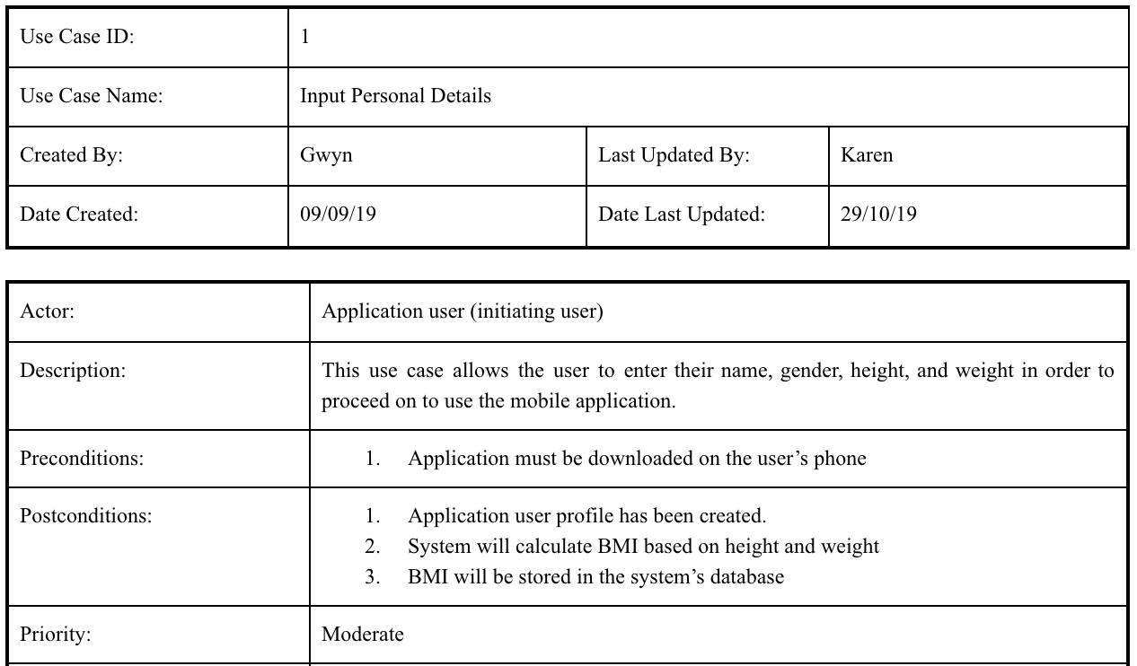

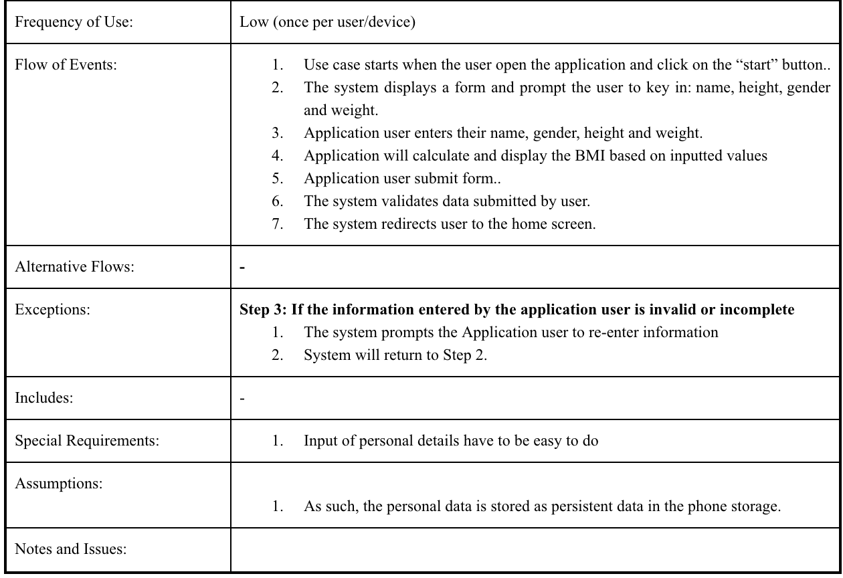

### **4.2.2 Update account details**

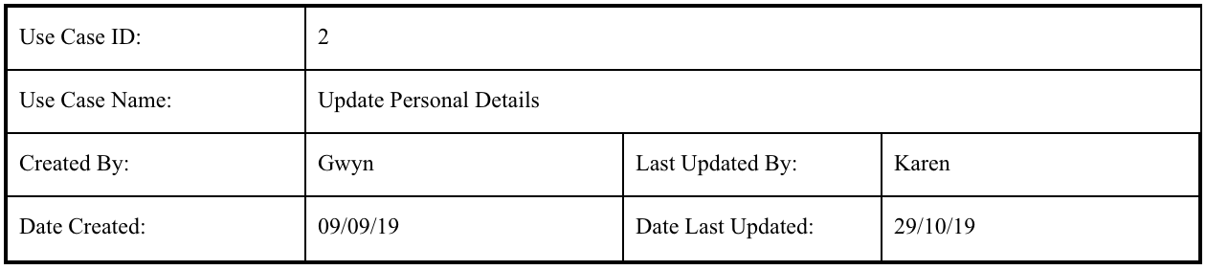

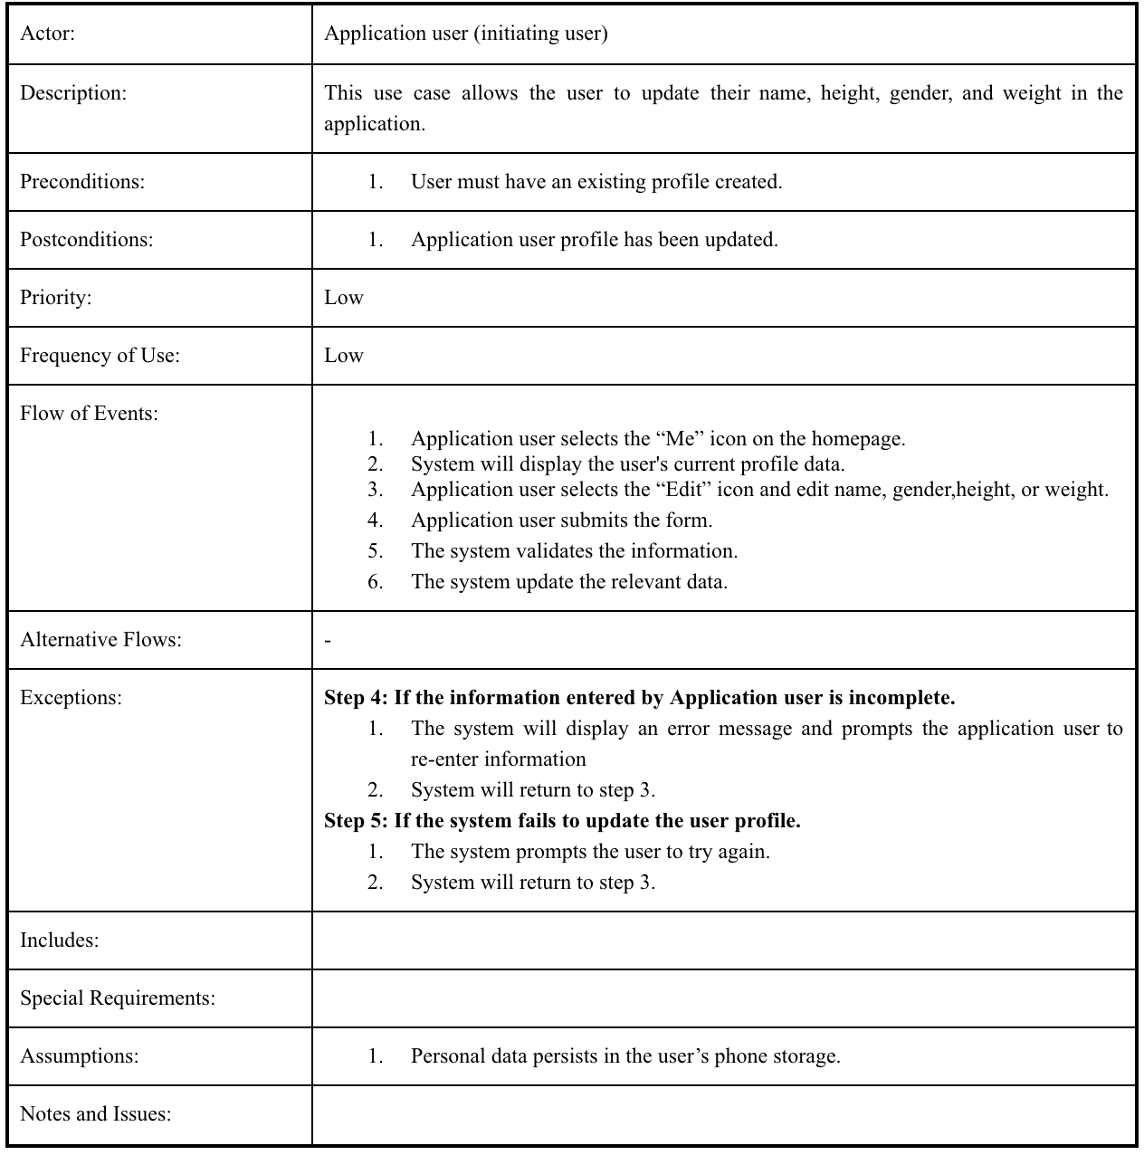

### **4.2.3 Food generator**

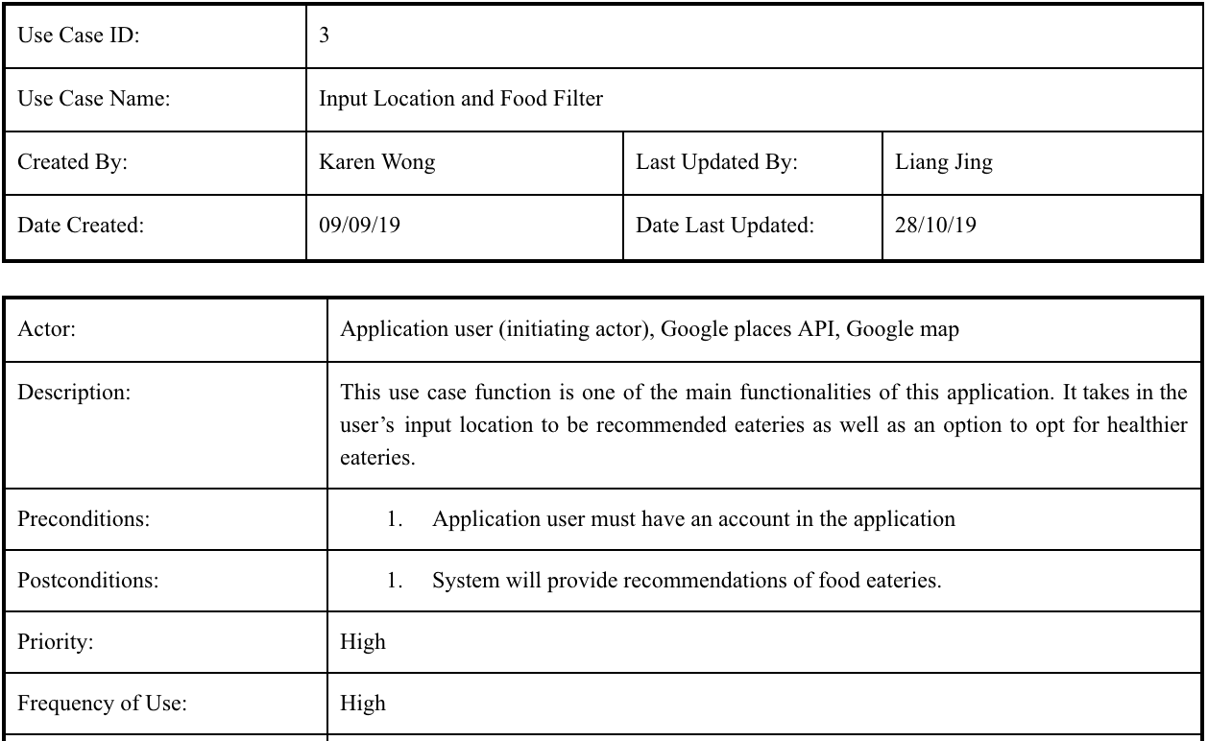

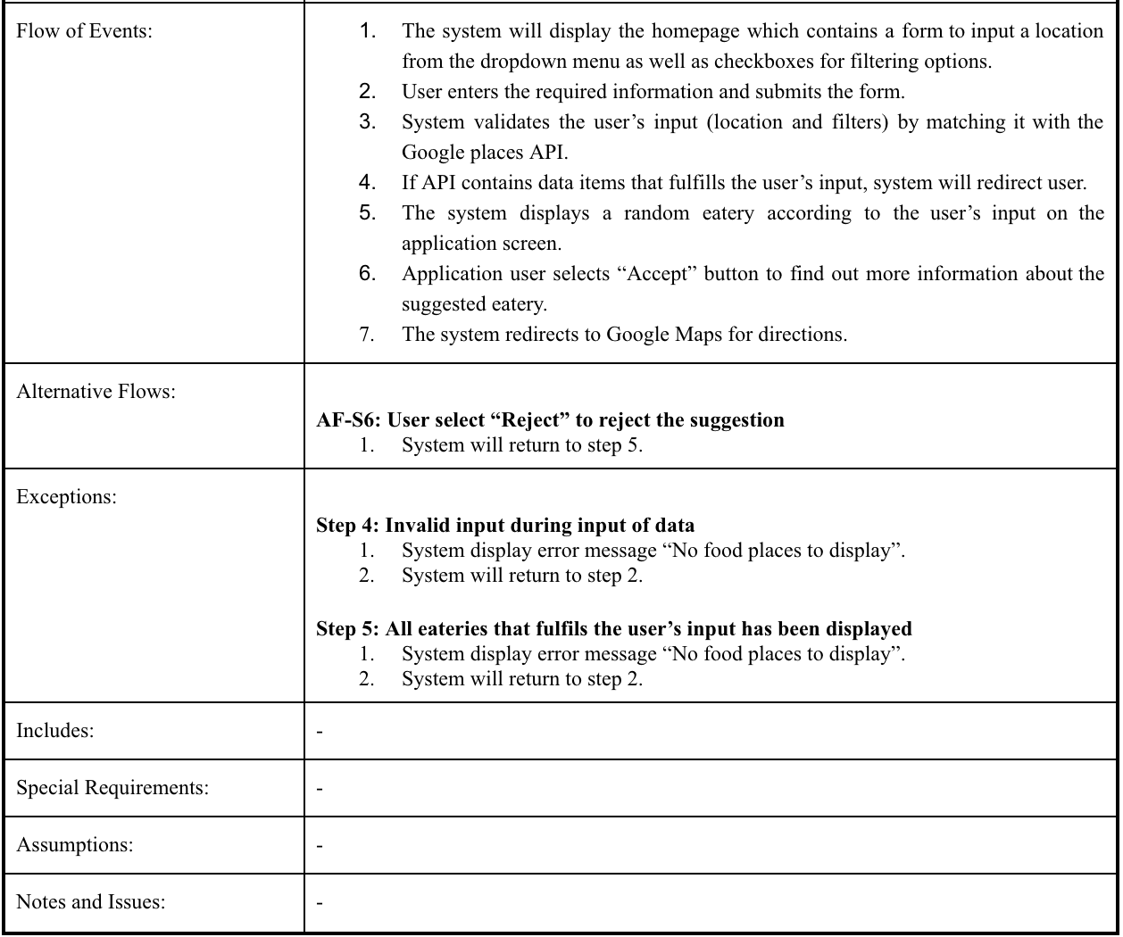

### **4.2.4 Locating Parks**

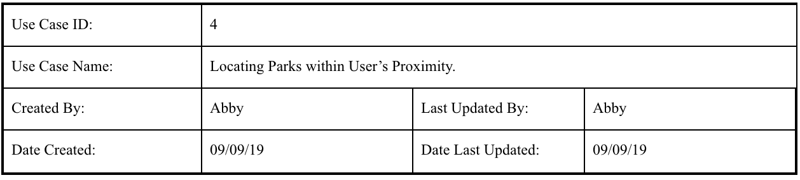

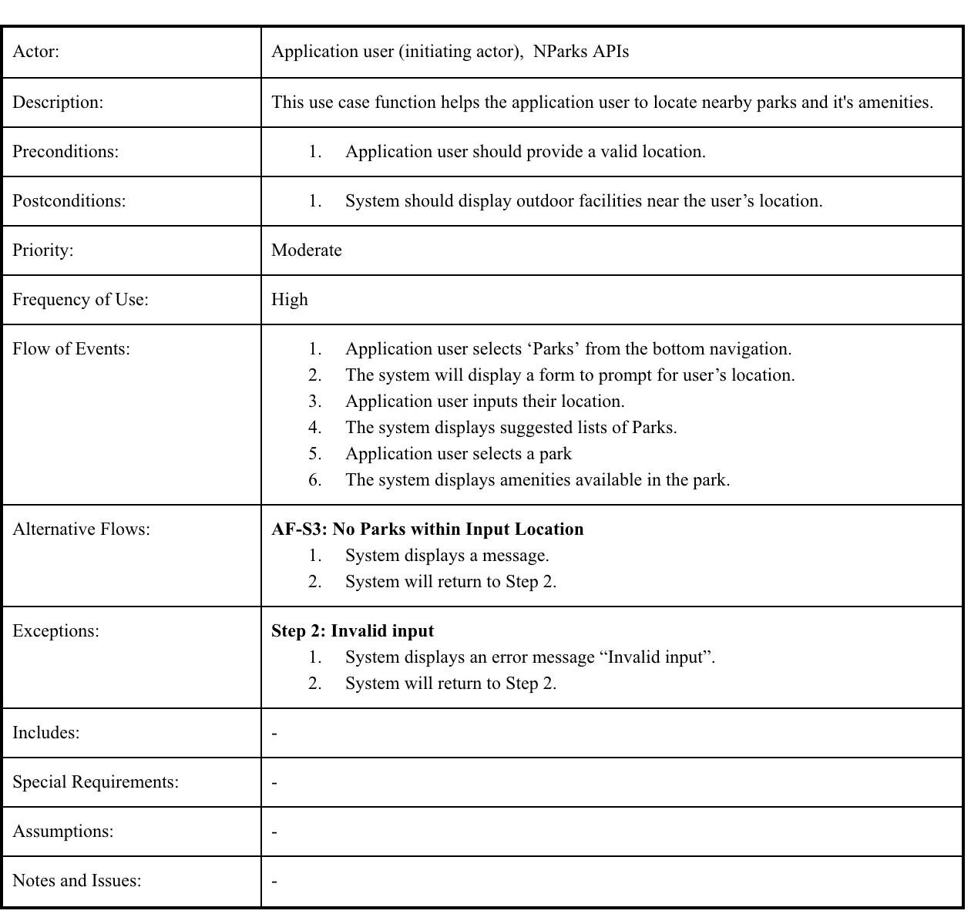

### **4.2.5 Calories counter and Exercise Recommendation**

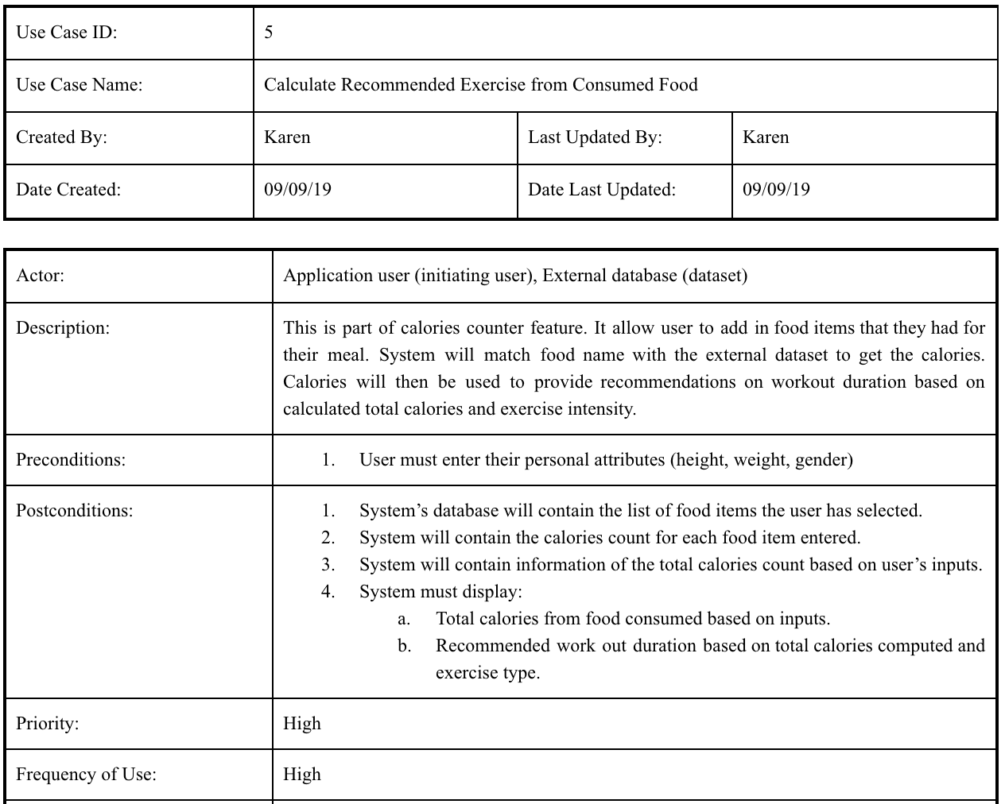

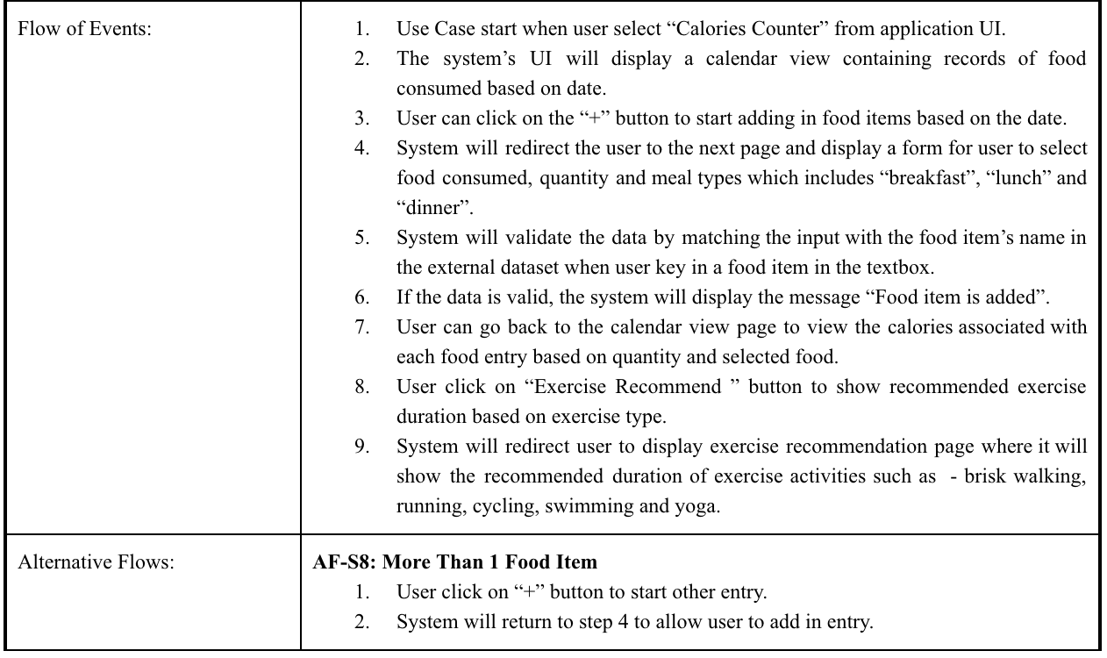



1. **Class Entity**

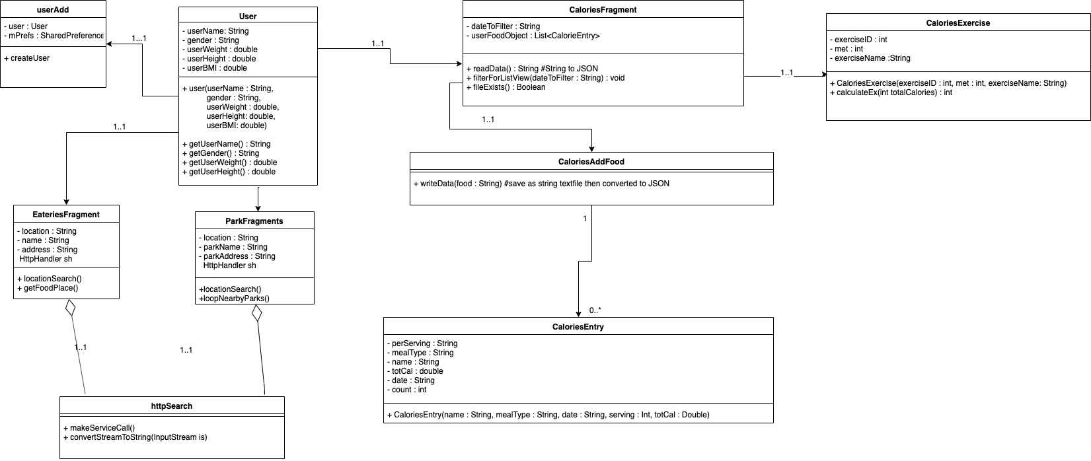

Figure - Class diagram of main classes and method

1. **Sequence diagram**

**6.1 Account Login and Update**

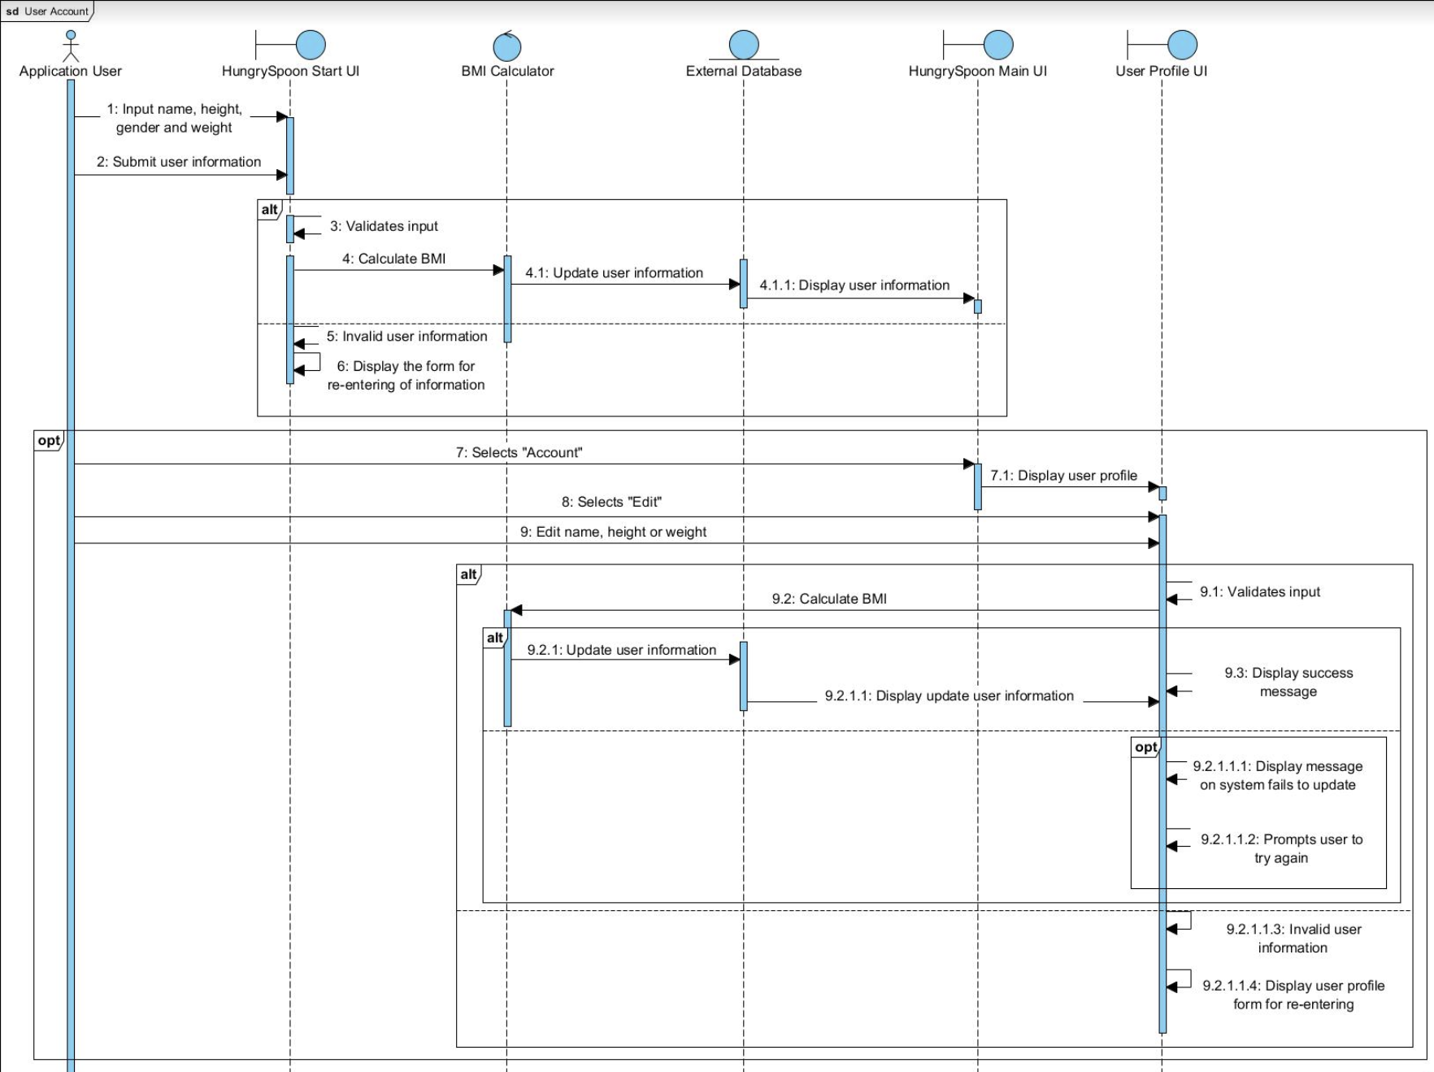

Figure 3 - Sequence diagram for user account

**6.2 Food Generator**



Figure 4 - Sequence diagram for food generator

**6.3 Calories Counter and Exercise Recommendation**

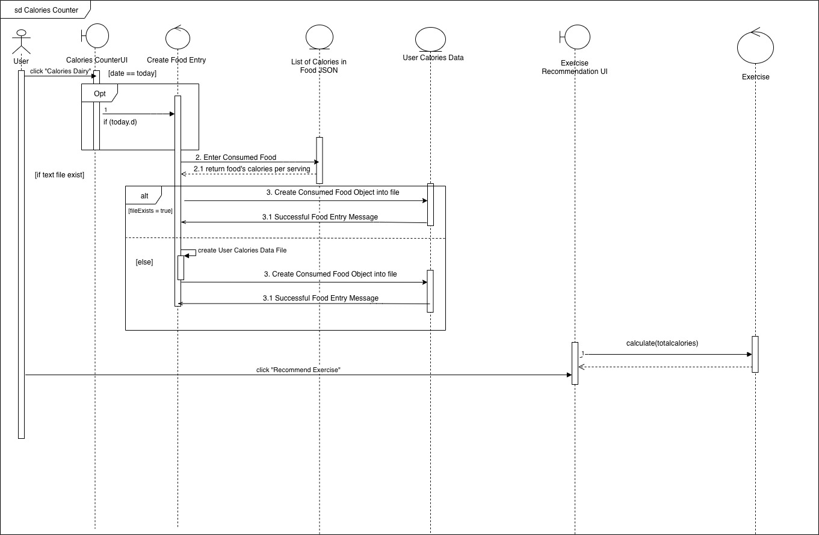

Figure - sequence diagram for calories counter

1. **Dialog Map**

In the following, state machine diagram for profile, food suggestion generator, exercise recommendation and display parks will be shown.

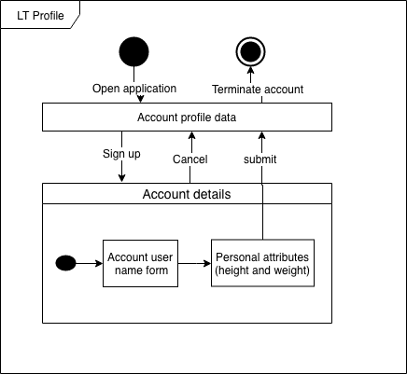

Figure 6 - dialog map for profile function

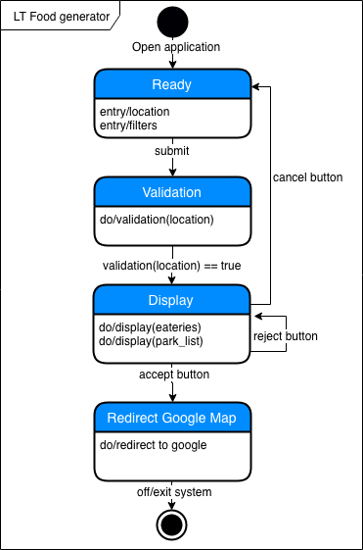

Figure 7 - dialog map for food generator function

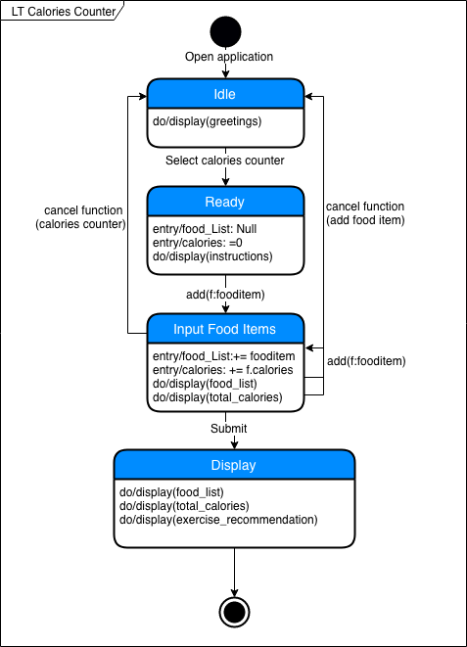

Figure 8 - dialog map for calories counter function

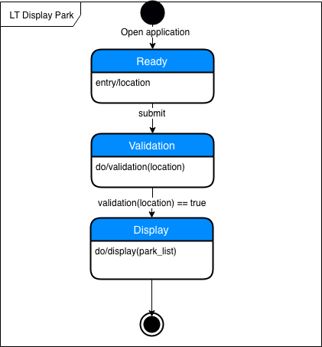

Figure 9 - dialog map for display park function

1. **System Architecture**

HungrySpoon Application will follow a layered architecture as following. In summary, there is 3 layers – presentation layer where java is used as the language for building the application on android studio. Application layers consists of all the API this application uses and the persistent data layer which uses MySQL as storage.

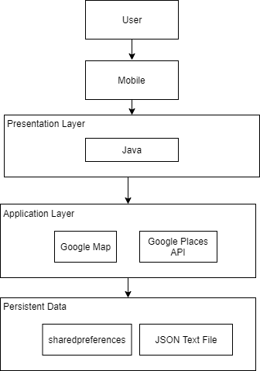

Figure 10 – HungrySpoon’s layered architecture

1. **Test Cases**

This program uses white box testing to test the flow of the system’s functionalities. In the section below, it will include the control flow graph (CFG) and the basic path tables.

## **8.1 Account Login and Update**

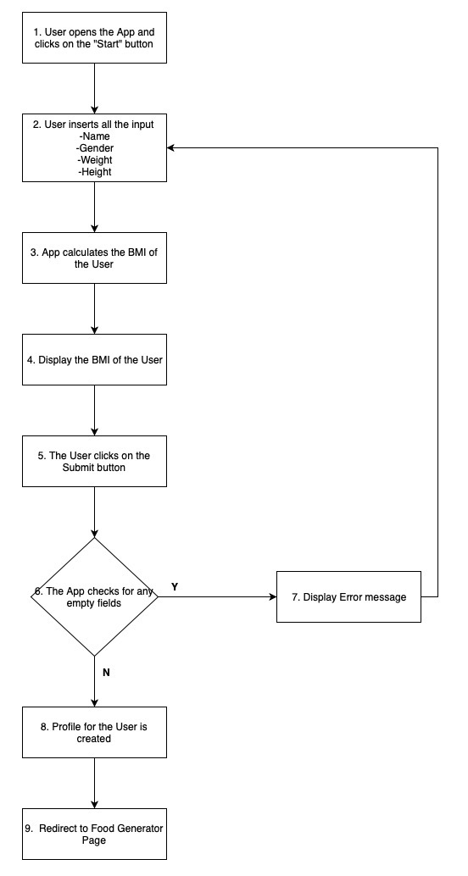

Figure -CFC for account login and update

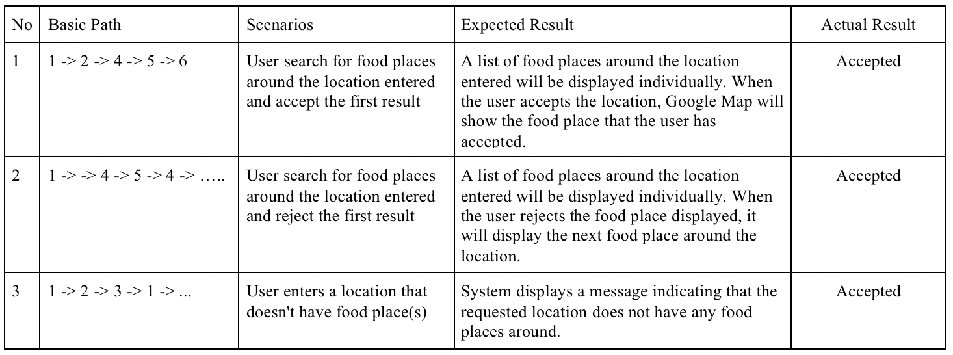

Figure - Basic path for account login

## **8.2 Locating of Park**

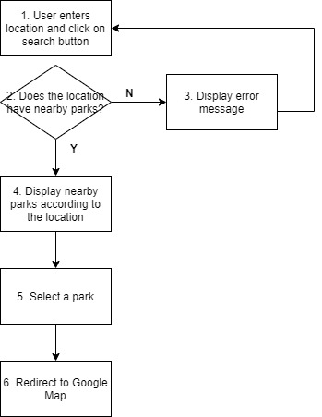

Figure - CFG for locating parks

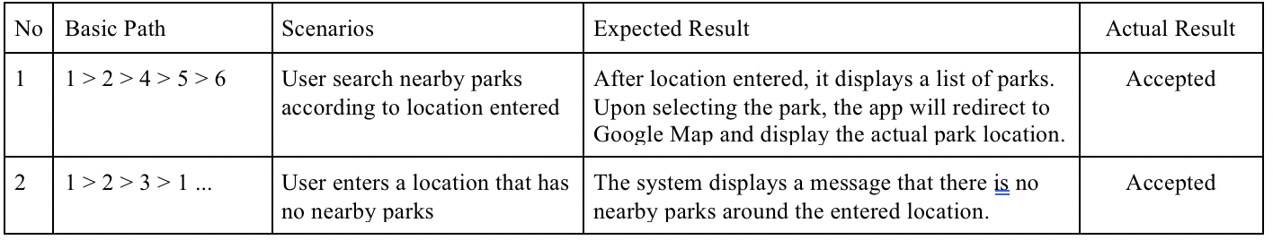

Figure - Basic path table for locating park

## **8.3 Calories Counter and Exercise Recommendation**

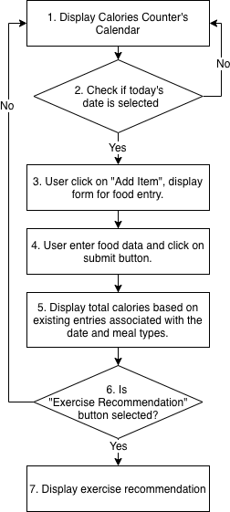

Figure - CFG for calories counter and exercise recommendation

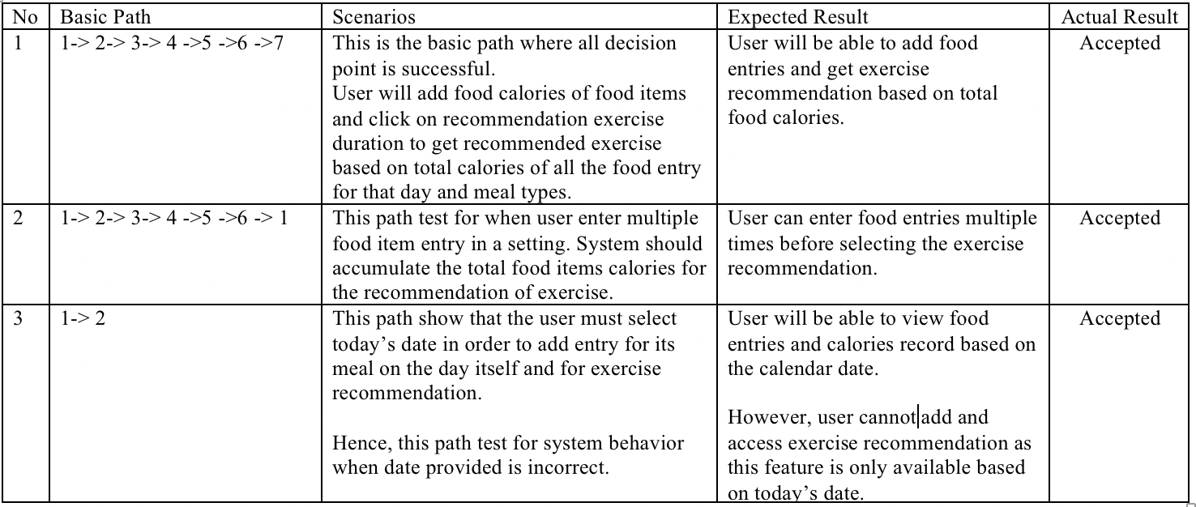

Figure – Basic path calories counter and exercise recommendation

1. **Appendix** 
   1. **Data dictionary**

|  |  |
| --- | --- |
| **Term** | **Definition** |
| HungrySpoon | This is the name of our application which provides (function) |
| Name | The username of the application user, it can be non-unique as it is to be displayed on the application for the user only. |
| Weight | A body’s relative mass, measured in kg. |
| Height | The measurement of a person from head to foot, measured in meters. |
| BMI | Body mass index, calculated by having a person weight (kg) divided by its height (meters). This index measure how healthy a person is based on its weight and height. |
| Location | The address of a place. |
| Healthy eateries | Eateries recognized by the health promotion board as an establishment that provides nutritious food. |
| Hawker centres | The cultural heritage of Singapore, a market like a place that contains individual stall selling food. |
| Parks | A public area with walkable path and greenery, containing an ecosystem. In this application, parks consist of Nparks in Singapore. For more information: <https://www.nparks.gov.sg/>. |
| Food eateries suggestion | Functionality in the HungrySpoon Application which provides suggestions for food eateries that fulfilled user’s requirements (inputs) one at a time. |
| Nearby park suggestion | Functionality in the HungrySpoon Application which will show the park name and location of nearby parks based on input location. |
| Food item | Food dishes a user may consume in a meal. For example, chicken rice, barley tea, herbal chicken soup, etc. |
| Calories | A measure of a unit of energy in kcal. Normally associated with the food we consumed. |
| Total calories count | The total amount of calories a user consumed based on the calculation of the total number of calories present in the food the person consumed. |
| Calories counter | Functionality in the HungrySpoon Application which calculates the total calories a person consumed based on food items entered. The system will then provide a recommendation on the brisk walking timing based on calories consumed. |
| Brisk walk | A relatively faster pace of walking than normal walking. |
| Recommendation of brisk walk duration | Based on total calories consumed provided by a user, a formula is applied that takes in a user’s BMI and gender to calculate an estimation of the duration of brisk walking he/she should do to burn off the provided calories. |

Table 3- HungrySpoon's Data dictionary

* 1. **UI Mockup**

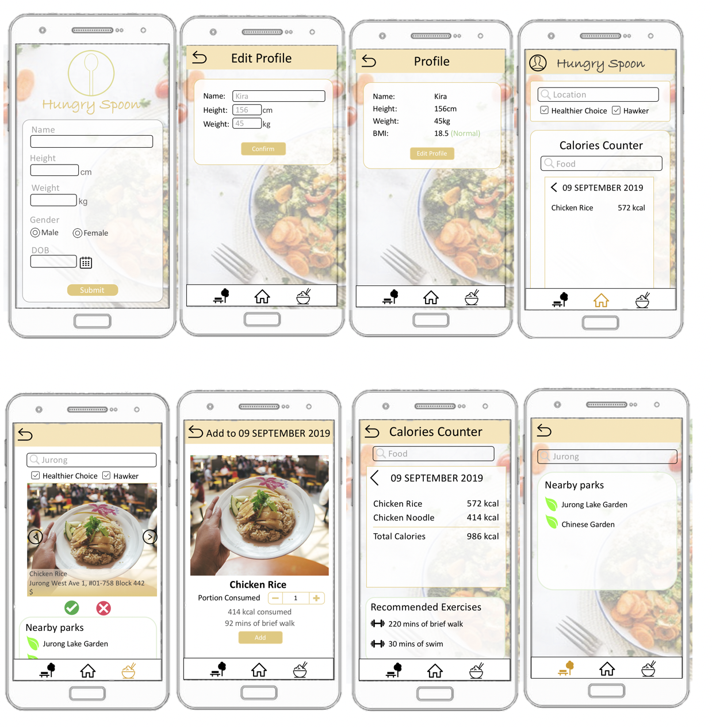

Figure 17 - UI interfaces of HungrySpoon application during the early stages